**STAT 40001/STAT 59800 Statistical Computing Fall 2020**

**Lab-11**

1. The data set *normtemp* in *UsingR* package contains measurements of 130 healthy randomly selected individuals. The variable temperature contains normal body temperature. Does the data support that the average body temperature is 98.6 0 F. Perform the hypothesis test.

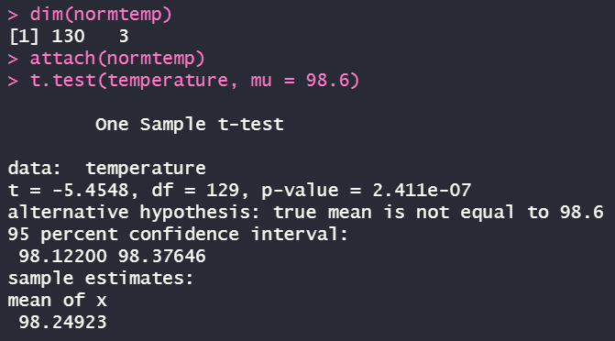

*(the p-value is less than 0.05, which means that we don’t have enough evidence to support Null Hypothesis, as in the average body temperature is not 98.6F)*

1. The waiting time (mins) of 100 bank customers before service is being rendered are provided below

0.8, 0.8, 1.3, 1.5, 1.8, 1.9, 1.9, 2.1, 2.6, 2.7, 2.9, 3.1, 3.2, 3.3, 3.5, 3.6, 4.0, 4.1, 4.2, 4.2, 4.3, 4.3, 4.4, 4.4, 4.6, 4.7, 4.7, 4.8, 4.9, 4.9, 5, 5.3, 5.5, 5.7, 5.7, 6.1, 6.2, 6.2, 6.2, 6.3, 6.7, 6.9, 7.1, 7.1, 7.1, 7.1, 7.4, 7.6, 7.7, 8, 8.2, 8.6, 8.6, 8.6, 8.8, 8.8, 8.9, 8.9, 9.5, 9.6, 9.7, 9.8, 10.7, 10.9, 11, 11, 11.1, 11.2, 11.2, 11.5, 11.9, 12.4, 12.5, 12.9, 13, 13.1, 13.3, 13.6, 13.7, 13.9, 14.1, 15.4, 15.4, 17.3, 17.3, 18.1, 18.2, 18.4, 18.9, 19, 19.9, 20.6, 21.3, 21.4, 21.9, 23.0, 27, 31.6, 33.1, 38.5

1. Construct a 95% confidence interval for waiting time for the bank customers.

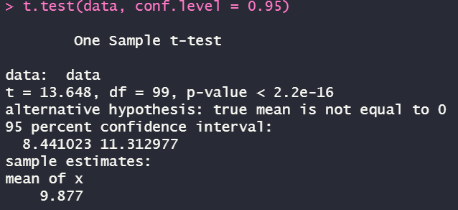

1. Construct a 99% confidence interval for waiting time for the bank customers.

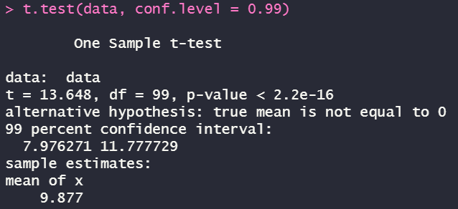

1. Do you have enough evidence to conclude that it takes on average more than 8 minutes before you are served?

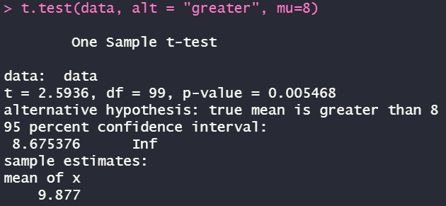

*(the p-value is less than significance level meaning that it’s in favor of the alternative hypothesis that it takes on average more than 8mins)*

1. In order to investigate the possible relationship between marijuana smoking and a deficit in performance on a task measuring short term memory--the digit span task from the Wechsler Adult Intelligence Scale two groups of ten subjects were tested. One group, the "nonsmokers," claimed not to smoke marijuana. A second group, the "smokers," claimed to smoke marijuana regularly. Below are the scores.

nonsmokers : 18,22,21,17,20,17,23,20,22,21

smokers : 16,20,14,21,20,18,13,15,17,21

Do we have enough evidence that the nonsmoker has higher score than smokers?

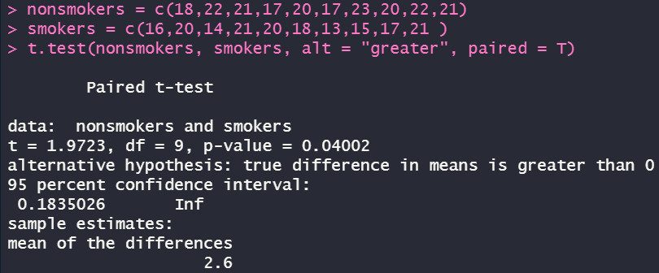  
*(The p-value is less than significance level of 0.05, which means that we can reject null hypothesis and say that the nonsmoker has higher score)*

1. An experiment was conducted to measure the pulse rate of students in a class. The students took their own pulse rate. They were then asked to flip a coin. If the coin came up heads, they were to run in place for one minute. Otherwise they sat for one minute. Then everyone took their pulse again. The pulse rates and other physiological and lifestyle data are given in the data.

<http://www.statsci.org/data/oz/ms212.txt>

1. Test the hypothesis whether there is a difference in pulse rate if the students were sitting.

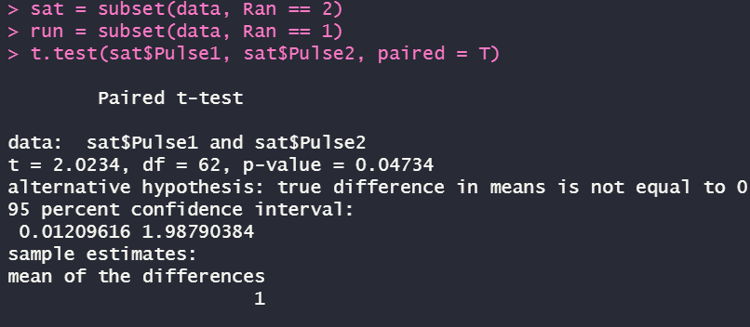

*(the p-value is less than 0.05, which means that out evidence is not strong enough to support the null hypothesis, such that there’s a difference in pulse rate.)*

1. Test the hypothesis whether the average pulse rate for running students is increased by 10 after they ran.

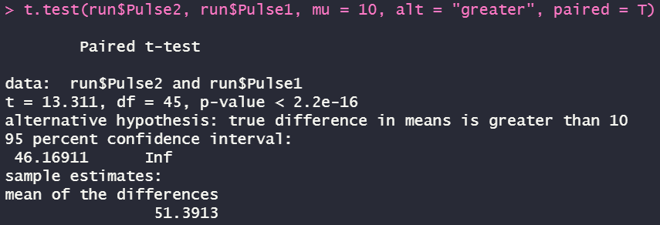

*(the p-value is extremely tiny which indicates that the alternative hypothesis is approved that the difference is greater than 10)*

1. Furness and Bryant (1996) compared the metabolic rates of male and female breeding northern fulmars (data described in Logan (2010) and Quinn (2002)).

|  |  |
| --- | --- |
| Sex | Metabolic rate |
| Female | 728 |
| Female | 1087 |
| Female | 1091 |
| Female | 1361 |
| Female | 1491 |
| Female | 1956 |
| Male | 526 |
| Male | 606 |
| Male | 843 |
| Male | 1196 |
| Male | 1946 |
| Male | 2136 |
| Male | 2309 |
| Male | 2950 |

1. Display the metabolic rate of Female and Male group using side-by-side boxplot







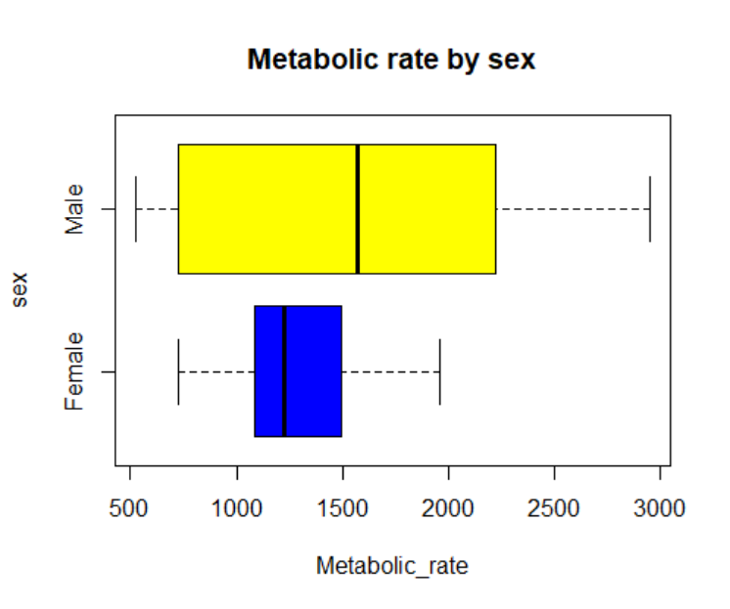

1. Test the hypothesis whether there is a difference in Metabolic rate based on gender

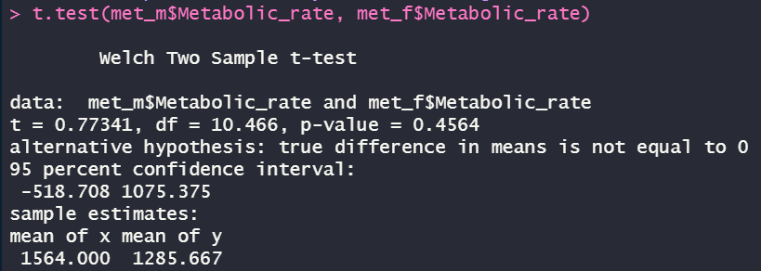

*(The p-value we test above is greater than 0.05, the default significance level, meaning that we don’t have the evidence to say that there’s a significant difference between the metabolic rate based on gender)*